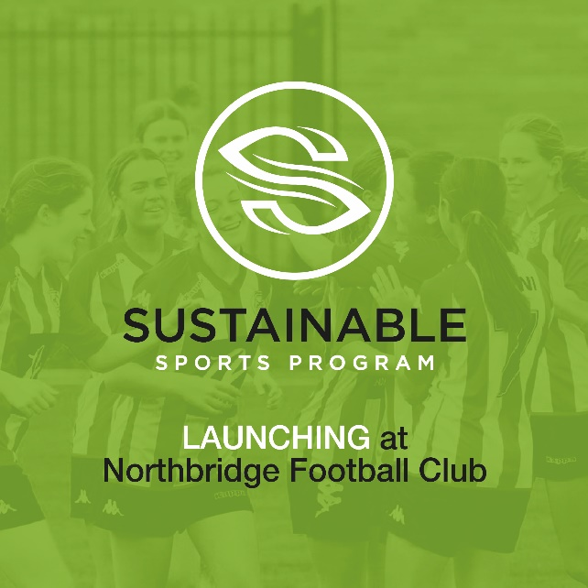
LAUNCHING APRIL 2021
BRIEFING KIT FOR NSFA CLUBS
The Sustainable Sports Program
Launch event:
Date: Sunday 18TH April 2021
Time: 10am-12 noon
Venue: North Turramurra Recreation Area
361 Bobbin Head Rd, North Turramurra NSW 2074

The kit contains:
1. Introductory communication to Club members
2. Short Q & A to use on NSFA website
3. Facebook copy for social media
4. Google Drive Link to a folder with
- video
- logo’s
- photos
* we have also made a short video to explain the program – link included.
5. About the co-founders of the program
Introduction to the Sustainable Sports Program
1. Introductory communication to Club members
This season our club [insert name] will be joining clubs across the NSFA to adopt the Sustainable Sports Program (SSP).
Created by two soccer mums Linda Curtis and Liz Courtney, the program was developed under a Federal Government grant, and piloted at Northbridge FC in 2020 to very pleasing results. The NSFA will be the first sporting association to launch Australia’s first grassroots Sustainable Sports Program this April, and we encourage all players and families to get onboard. The Sustainable Sports Program (SSP) is aimed at reducing the carbon footprint of community sport clubs nationally over the next three years and inspiring youth to have a voice for change.
The SSP is based on a series of activities, events and initiatives that combine to create greater awareness of options, behavioural choices, provide youth the chance to lead and engage in their future world to make a positive impact on reducing their local sports club’s carbon footprint. A key element of the SSP is its leadership role with youth and their families. Sustainable Youth Ambassadors will be appointed to help carry out the initiatives and bring greater grassroots engagement across all age groups from youth teams to seniors.
In brief, the SSP includes –
A Sustainable Canteen Web based App, to assist with lowering carbon emissions to a carbon-neutral canteen over the next 3 years.
New 3-tiered Recycling Bins that will allow for a higher degree of recycling of plastics, glass, and food wastes and a Recycle, Reuse, Remind conversation with all teams.
A Return and Earn program for youth to encourage collection of eligible bottles.
Recycle for Goodness Weekend to pass on boots, shorts, tops to marginalised youth in country areas and national indigenous sports program.
Visual recognition of the Sustainable Sports Program (SSP) Charter will be displayed on boards placed in prominent areas and internal change rooms

To find out more about the program go to:
www.thesustainablesportsprogram.com.au

View short video about the program:
https://vimeo.com/526463962

Youth Ambassador – Message for the youth of your club from April
https://vimeo.com/526465041

What are the key initiatives if the Sustainable Sports Program?
Key initiatives include:
1. Leadership roles for Sustainable Sports representatives of school age and beyond to drive their passion and our projects at a grass level in their year group.
2. Canteen Sustainable Web App, through the creation of a new app designed to assist the reduction of carbon emissions with a goal to reduce, replace and create a carbon neutral canteen over the next 3 years. Drive to use Keep Cups, bring water bottles and provide a FREE Refill water station for all players and attendees
3. New Recycling Bins: Implementation of new recycling bins that allow for a higher degree of recycling of plastics, glass, and food wastes.
4. Recycle for Goodness Weekends: Two held per year to donate clothes and boots to rural towns in Australia, indigenous communities and those impacted by hardships of fires, droughts and floods.
5. Bush and Beach Environmental Clean-up Weekend: annual clean up engagement of a nominated local area for youth to connect with the issues around littering, marine and ocean impact, bush and environment.
6. Recycle, Reuse, Remind ourselves to be sustainable: Visual recognition of the Sustainable Sports Program (SSP) Charter via display boards placed in prominent positions and internal change rooms
7. Return and Earn program, providing youth with an opportunity to collects eligible containers and exchange these for $$ for their club and to encourage recycling around their community and club.

The Sustainable Youth Ambassador Engagement
As part of the Sustainable Sports Program, your club is offered an amazing opportunity for youth-players to become environmental and well-being leaders in the Football Community by embracing the Sustainable Sports Program (SSP). Up to 10 players are invited to step-up in 2021 to represent your club (a separate e-mail will be sent to cover all of these details including copy for an e-mail to go to out to your club players and for use on a website).
Role Description of a Youth Ambassador:
- Take a lead role in managing the waste from your team
  - Ensuring any left-over rubbish from your game is put in the right bins on the ground or visiting home grounds
  - Encourage team members to bring water bottles to training and games
  - Encourage parents and family members to bring reusable cups to trainings and matches
- Promote the Recycling for Goodness weekend to be hosted by the Club Be a participant in the volunteer roster system to facilitate donated items.
- Promote and participate in the local Bush and Beach clean ups (1 day in 2021 affiliated with Clean Up Australia).
- Promote and attend educational sustainable events to be hosted by the club.
- Engage with your team and encourage new ideas from team players, family members and where possible log sustainable environmental innovations via Sustainable Sports Program tab on our clubs website.
- Youth Ambassadors can join a zoom call generally once a month online hosted by the Sustainable Sports team to discuss sustainable ideas, hear from a guest speaker and provide a platform for interclub connections.

What to do next:
1. Put a short 1-2 paragraphs about this on your club’s website – plus provide a link to the SSP website/ Read more at www.sustainablesportsprogram.com.au
2. Promote on Facebook/on your club’s social media
‘This season our club [insert name] will be joining with all clubs across the NSFA to adopt the Sustainable Sports Program (SSP). Created by two soccer mums Linda Curtis and Liz Courtney, the program was developed under a Federal Government grant, and piloted at Northbridge FC in 2020 to very pleasing results. The NSFA will be the first sporting association to launch Australia’s first grassroots Sustainable Sports Program this April.
Read more at www.sustainablesportsprogram.com.au
Link to video about the program to watch: https://vimeo.com/526463962
3. Email out to all club members – copy (1) in the briefing document
4. Logos and a selection of images, videos in a google folder
https://drive.google.com/drive/folders/1AmIJiX-1K6hfISL2Vwo7nfDFSxLhWKRz?usp=sharing
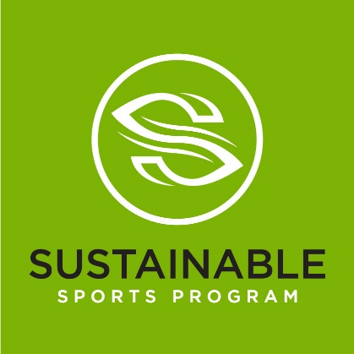

About Linda Curtis and Liz Courtney – two soccer mums who created the idea
About Linda Curtis:
Project Manager/Family Educator, MBus
Experienced project manager working in corporate and not for profit organisations for over 20 years. Last 5 years worked in schools, firstly as an office Finance Manager and presently as the Family Educator for St Mary’s Primary School, North Sydney. In this role Linda has launched new community volunteer programs such as ‘Blessing Meals’ for those in need and last year organised food and toiletry drives for Jesuit Refugee Services and an online appeal for Vinnies. Linda recognised the need for a youth ambassador and voice in the environment space when her daughter, Northbridge FC U 17’s, organised a NSW government petition to ban plastic bags in NSW. For her efforts in obtaining more than 10,000 hard copy signatures she was awarded 2018/2019 Australian Geographic Young Conservationist of the Year. She continues her speaking platform in this space and was awarded 2019 Willoughby and North Sydney Young Citizen of the Year.
About Liz Courtney
Documentary Director/ Producer, TedX Speaker, awarded ‘100 Women of Influence’ in Australia
Liz has produced over 50 documentaries in the last 12 years with a strong focus on science based factual programs around Climate Change and Sustainability. Liz wrote and directed one of the largest climate series in the past decade, The Tipping Points, a 6 x 1 hr series recorded in three languages in the field and released in over 54 countries. Co- creator of Youth4planet, Liz is passionate about giving youth a voice for their future, through the development of strong social impact programs, that are scalable, that use digital technologies for delivery and enable action from local to global communities.
Says Liz, “The gamechangers are the next generation – we need to ensure we provide our youth with the tools to find their voice for change and the means to deliver change in their community. One voice, one community, one planet - Youth4planet.com’.

